Assignment 35.3

Problem Statement:

● Explain and perform Importing table contents from Mysql to Hive using Sqoop.

● Explain and perform Importing table contents from Mysql to HBase using Sqoop.

● Explain the procedures performed, Share the screenshots of commands and results for the same.

● Explain and perform Importing table contents from Mysql to Hive using Sqoop.

Employee table in mysql

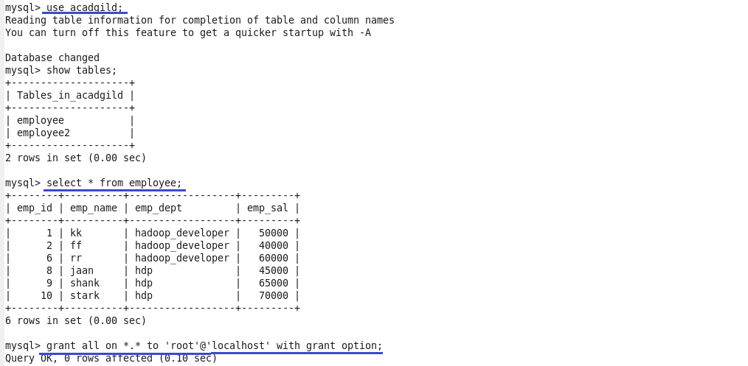

Command to import mysql data to hive using sqoop.

C:\Users\612883\Desktop\35.3.11.png

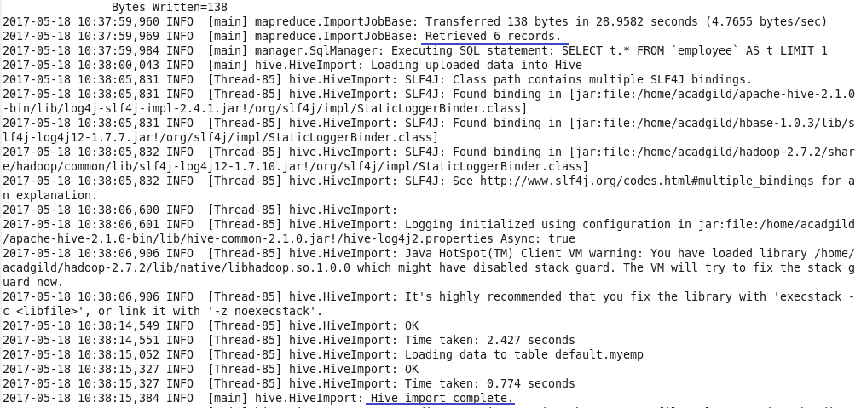

Table myemp created in hive and contents of table employee in mysql are loaded in myemp.

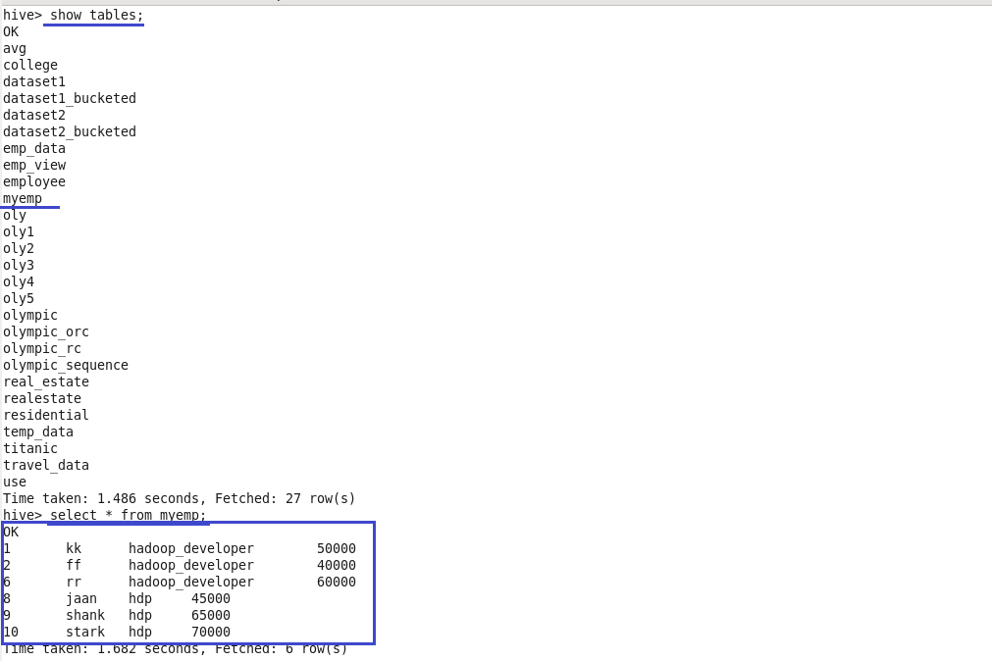

● Explain and perform Importing table contents from Mysql to HBase using Sqoop.

Commands used to display all the columns present in the table **employee and its contents** and to grant superuser permission to root.



 Created a new table in Hbase with the name**academp**and column family as**emp_details**

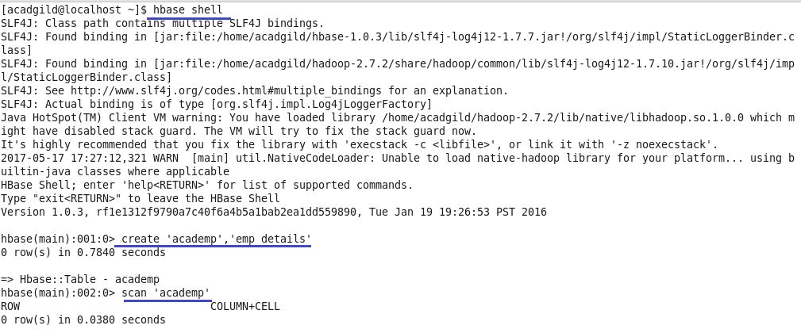

The command used to import data from mysql table to hbase table academp using sqoop.

C:\Users\612883\Desktop\35.3.23.png

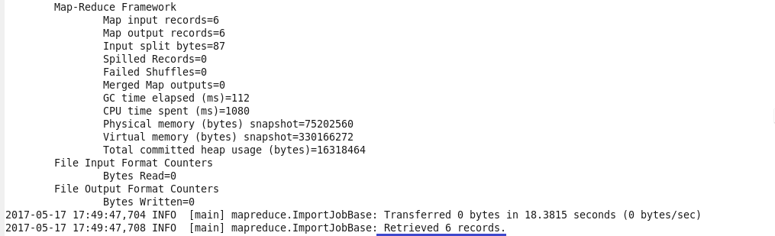

Using scan command the contents of the table academp in hbase are displayed.

